**Comparison of Modeling prediction vs Experimental Data**

**utilizing Montecarlo Simulation (Geant4)**

**for Au-198 Decay scheme**

Table of Contents

1. Summary 2

2. Introduction 3

3. Experimental Procedure 3

A. Equipment Preparation and setup 3

B. Statistics of Counting 4

4. Mathematical Modeling 4

A. Modeling Procedure 5

B. Data Analysis 5

5. Conclusion 6

6. Reference 6

List of Tables

Table 3‑1: Equipment (Major Component). 3

Table 4‑1: Geant4 Setup. 5

List of Figures

Figure 2‑1: Decay Scheme of Au-198 [Ref 3] 3

Figure 3‑1: Equipment setup 4

Figure 3‑2: Experimental Gamma Count (Au-198) 4

Figure 4‑1: Simulation Data collected. 5

Figure 4‑2: Data Analysis using ROOT. 6

# Summary

Au-198 is used for radiotherapy in some cancer treatments and radioactive tracing for sediment and water flow. In this work, a Montecarlo simulation (Geant4 ecosystem) along with a simple data collection network was constructed to investigate an isotope of gold (Au 198) decay scheme. In the experimental data collection, Au-198 produced the radiation which was detected by a Geiger counter. The Geiger counter output was coupled with High Voltage Power supply to produce signals which were analyzed by the single-channel analyzer and a counter/timer. An oscilloscope was used to troubleshoot the signal at various points along the processing path. Examination of the signal exiting the coupling box was utilized to plot count rate at the plateau region. Gamma counts were measured with a mean of 420 (KeV). In the Montecarlo Simulation ecosystem Geant4 took kit was used to simulate Au-198 and collect Montecarlo data. These data are plotted using ROOT tool. Gamma counts were evaluated in the simulation at 420.7 (KeV) with standard deviation of 0.269 (KeV). Collectively, the hands-on experience with the Geiger counter described here enhanced the comprehension of the inner workings of the electronic tools along with its operational procedures required for the detection, measurement, and characterization of ionic radiation. Furthermore, the utilization of a Geant4 described enhanced the comprehension of the inner workings of the Geamt4 framework implementing Montecarlo simulation.

# Introduction

The Au-198 decay scheme is explained by solving the three-dimensional Schrodinger equation for the two potentials of infinite well and harmonic oscillator [Ref 1]. In addition, the scientific computing community has provided a variety of numerical approximation techniques like Geant4 framework [Ref 2] to solve algorithms. This effort compares the Montecarlo data collect vs the experimental data collected for the gamma count produced be a radioactive isotope of Au-198 as it undergoes a beta decay to stable Hg-198 with a half time of 2.69464 days [Ref 3].

The Q-value of the beta decay is 1372.5 (KeV) with two major decays branches. First branch of beta decay produces gamma radiation from excited Hg-198 at 2+ spin with 411.8 KeV. The second branch of beta decay produces gamma radiation from excited Hg-198 at 2+ spin with 1087.7 Kev. In theory the excited state of Hg-198 can be contributed to a single unpaired neutron on 1i(13/2) nuclear shell state and a single unpaired neutron on 2g(9/2) nuclear shell state. The g and I spectroscopy notations produce positive spin and (13/2 – 9/12) produces a total angular moment of 2 at the lowest energy level. This decay scheme is best illustrated in the figure below.

Figure 2‑1: Decay Scheme of Au-198 [Ref 3]

# Experimental Procedure

A simple data collection network (experimental data) is configured using the following procedure.

## Equipment Preparation and setup

The equipment is consistent of Geiger Counter, HV power Supply, Coupling Box, Oscilloscope, Single Channel Analyzer (SCA), Counter/timer.

Table 3‑1: Equipment (Major Component).

|  |  |
| --- | --- |
| Equipment | Information |
| Oscilloscope | Tektronix – 2235A 100 MHz |
| SCA | Ortec-551 |
| Counter/Timer | Ortec 773 |
| Geiger Counter | GM Tubes, Proportional Counter |

All equipment is connected as shown below.

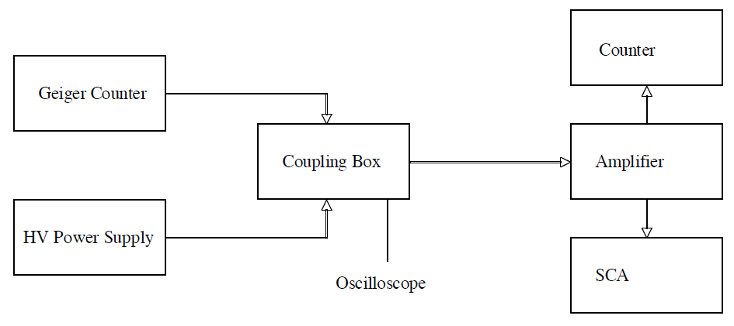

Figure 3‑1: Equipment setup

## Statistics of Counting

An oscilloscope was used to troubleshoot the signal at various points along the processing path. Once the set up was completed, used the counter/timer in the repeat mode to obtain the statistical distribution of gamma counts. Used fifty ten second counts for counting sample. It is important to note that gamma count of 420 KeV had the maximum amount of frequency as it is illustrated in the figure below.

Figure 3‑2: Experimental Gamma Count (Au-198)

# Mathematical Modeling

Monte Carlo simulation is a technique that predicts outcomes of uncertain events.

## Modeling Procedure

Geant is a software package composed of tools which can be used to accurately simulate the passage of particles through matter [Ref 2]. All aspects of the simulation are included in the table blow.

Table 4‑1: Geant4 Setup.

|  |  |
| --- | --- |
| Simulation | Implementation. |
| Geometry Definition | NUCE427LAB02 ::DetectorConstruction |
| Physics List | NUCE427LAB02::PhysicsList |
| Action Initializations | NUCE427LAB02:: ActionInitialization |
| Primary Generator | NUCE427LAB02:: PrimaryGeneratorAction |
| Runs and Events | NUCE427LAB02:: RunAction |
| Detector Response. | NUCE427LAB02:: SteppingAction |
| Visualization | G4VisExecutive |

The geometry is set up within the DectecorConstruction class. It has a standard world geometry which is derived from G4Box class. It has an array of detectors shaped like a Position Emison Tomography. Every element in array is derived from G4Box class rotated and translated to form a cylinder. The physics is set up within PhysicsList class. It is derived from G4VModularPhysicsList class and entails G4EmStandardPhysics objects, G4DecayPhysics objects and G4RadioactiveDecay Physics objects. It has an actionInitialization class derived from G4VuserActionInitialization class. It intantiates, an object of RunAction, EventAction, Stepping Action and StackingAction. The generation of primary particles is implemented in PrimaryGeneratorAction class. It is derived from G4VUserPrimaryGeneratorAction. The GeneratePrimray method defines Au-198.

## Data Analysis

The simulated data is analyzed for the case of 10000 beta decays. It is significant to note that the gamma count with the peak of 3048 times has energy of 424 KeV.

Figure 4‑1: Simulation Data collected.

The average value of the energy deposited in the sensitive detector is 0.4207 MeV with standard deviation of 0.2694. As it is illustrated below.

Figure 4‑2: Data Analysis using ROOT.

# Conclusion

Comparison between numerical and experimental results is two percent. It is shown that there is an agreement between numerical models and experimental data for gamma radiation of 420 (KeV). However, the gamma radiation of 1087 (KeV) was present in neither experiment nor simulation. Consequently, it is shown that this approach is not correct for either experimental data collection or numerical modeling and alternative experimental set up and mathematical modeling must be pursued. In general, simulation allows one to explore ‘what if’ questions and scenarios without having to experiment on the system itself. It helps one to identify bottlenecks in material, information, and product flows. It helps gain insight into which variables are most important to system performance.

# Reference

[1] Kenneth S. Krane (1988). Introductory Nuclear Physics, page 121 (Nuclear Shell Model)

[2] https://www.geant4.org/

[3] https://en.wikipedia.org/wiki/Gold-198